**PROJECT REPORT: ENVIRONMENTAL MONITORING**

**PHASE - 5**

**CHAPTER: 1 INTRODUCTION**

The Environmental Monitoring Program is a comprehensive initiative aimed at safeguarding our natural ecosystems and ensuring the well-being of both human and ecological communities. In an era of rapid industrialization and urbanization, it is imperative to monitor and mitigate the impacts of human activities on the environment. This program seeks to achieve a harmonious balance between development and conservation by employing cutting-edge technologies and rigorous data analysis.

Through systematic data collection, analysis, and reporting, this program aims to track key environmental parameters such as air quality, water quality, biodiversity, and land use patterns. By doing so, we can identify trends, assess potential risks, and implement targeted interventions to preserve the integrity of our ecosystems.

Collaboration between governmental agencies, research institutions, non-profit organizations, and the community at large is integral to the success of this program. Together, we will work towards a sustainable future where the natural environment thrives alongside human progress.

**CHAPTER: 2 DESCRIPTION**

Environmental monitoring is a crucial practice designed to track and assess the condition of our natural surroundings. It involves the systematic collection, analysis, and interpretation of data related to various aspects of the environment, including air, water, soil, biodiversity, and climate. The primary goal of environmental monitoring is to gain insights into the health and stability of ecosystems, as well as to detect any changes or potential threats caused by human activities or natural phenomena.

Through the use of advanced technologies, such as remote sensing, sensor networks, and data analytics, environmental monitoring provides valuable information for informed decision-making. It helps guide policies, regulations, and conservation efforts to ensure sustainable resource management, protect public health, and preserve biodiversity.

Environmental monitoring programs are typically conducted by government agencies, research institutions, non-profit organizations, and private sector entities, often in collaboration with localcommunities. By fostering a culture of environmental stewardship and accountability, these programs contribute to a more resilient and balanced coexistence between human societies and the natural world.

LIMITATIONS

* Spatial and Temporal Variability
* Cost and Resource Constraints
* Technological Limitations
* Complexity of Environmental Interactions
* Access to Remote or Sensitive Areas
* Community Engagement and Participation

CHAPTER: 3 MODULE

BLOCK DIAGRAM

SENSOR OUTPUT DEVICES

POWER SUPPLY

HUMIDITY SENSOR

TEMPERATURE SENSOR

WATER SENSOR

AIR SENSOR

SOUND SENSOR

MICROCONTROLLER

LCD DISPLAY

CONTROL INTERFENCE

ALARAM

DATA STORAGE

BLOCK DIAGRAM DESCRIPTION:

1.Microcontroller/Main Processing Unit:

This is the brain of the system, collecting data from sensors and process it and managing output actions and displays.

2.Sensor:

Humidity sensor: Connects to the microcontroller to measure humidity.

Temperature sensor: Connects to the microcontroller to measure temperature.

Water sensor: Connect to the microcontroller to measure water.

Air sensor: Connect to the microcontroller to measure air.

Sound sensor: Connect to the microcontroller to measure sound.

3.Communication Interface:

Enables the microcontroller to communicate with external devices or a computer. This can be Wi-Fi, Bluetooth or wired connections like USB or Ethernet.

4.Display:

Shows real time data readings, alerts, or system status

5. Alaram/Notification System:

This can be an audible alarm, LED indicator, or any other signalling device that alerts the user when the desired value goes out of range.

6.POWER SUPPLY:

Provides power to the entire system. This could be batteries, solar panels, or a direct power source.

7.DATA STORAGE:

Where the data can be logged for historical analysis. This could be an SD card, onboard memory, or cloud storage.

8.CONTROL BUTTONS/INTERFACE:

Allows the user to interact with the system, set thresholds, or view historical data.

CHAPTER: 4 PROGRAM

**cpp**

**#include <Wire.h> // Include the Wire library for I2C communication**

**// Define the addresses of your sensors**

**const int humiditySensorAddress = 0x3F;**

**const int temperatureSensorAddress = 0x4A;**

**const int soundSensorPin = A0;**

**const int waterDetectorPin = 2;**

**const int airFlowSensorPin = A1;**

**void setup() {**

**Serial.begin(9600); // Initialize serial communication**

**Wire.begin(); // Initialize I2C communication**

**pinMode(waterDetectorPin, INPUT);**

**}**

**void loop() {**

**float humidity = readHumidity(humiditySensorAddress);**

**float temperature = readTemperature(temperatureSensorAddress);**

**int soundLevel = analogRead(soundSensorPin);**

**bool isWaterDetected = digitalRead(waterDetectorPin);**

**int airFlow = analogRead(airFlowSensorPin);**

**// Process and display the data**

**Serial.print("Temperature: ");**

**Serial.print(temperature);**

**Serial.println("°C");**

**Serial.print("Humidity: ");**

**Serial.print(humidity);**

**Serial.println("%");**

**Serial.print("Sound Level: ");**

**Serial.println(soundLevel);**

**Serial.print("Water Detected: ");**

**Serial.println(isWaterDetected ? "Yes" : "No");**

**Serial.print("Air Flow: ");**

**Serial.println(airFlow);**

**// Add code to transmit data to your desired destination or take actions based on sensor readings**

**delay(10000); // Delay for 10 seconds before taking the next reading**

**}**

**float readHumidity(int address) {**

**// Implement code to read humidity from the I2C sensor**

**// Return the humidity reading**

**}**

**float readTemperature(int address) {**

**// Implement code to read temperature from the I2C sensor**

**// Return the temperature reading**

**}**

**// Implement similar functions for other sensors**

**void processSensorsData(float humidity, float temperature, int soundLevel, bool waterDetected, int airFlow) {**

**// Add your logic for data processing here**

**}**

CHAPTER: 5 RESULT

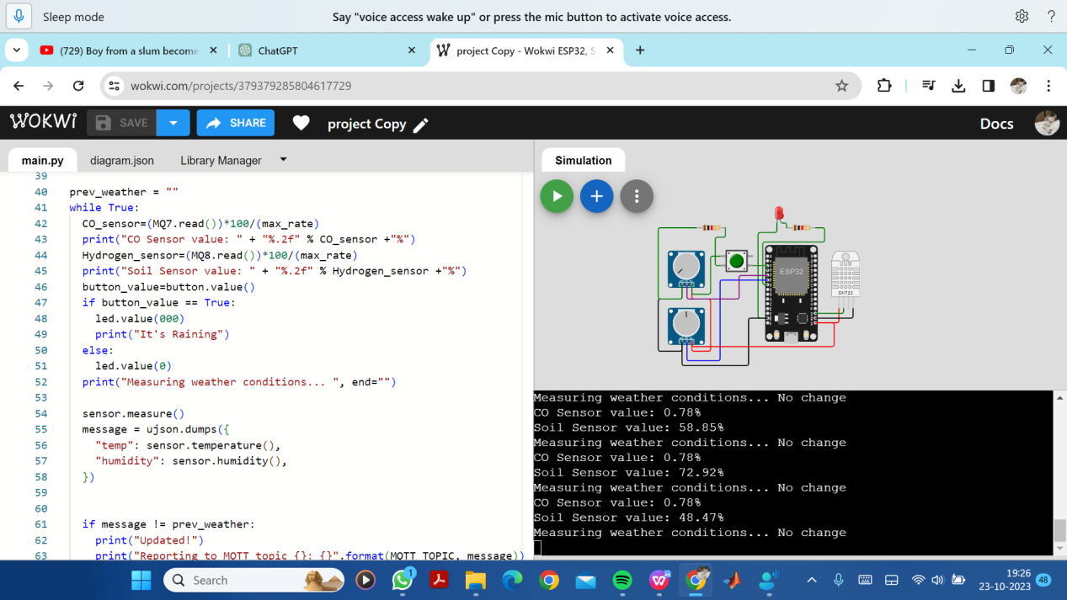

CONCLUSION

In the pursuit of a sustainable future, our Environmental Monitoring Program has been a cornerstone of informed decision-making. Through meticulous data collection and analysis, we've uncovered vital insights into our environment's health. This initiative has not only safeguarded our ecosystems but has also empowered communities to take proactive steps towards conservation. As we continue to evolve, this program stands as a testament to our commitment to a harmonious coexistence with the natural world.